**TOOL TIPS**

**How to use Tool Tips in Power BI?**

* Why we use Page Navigation?
* To Show one visualization on another

Step 1: First Create Target Page 🡪 Under Visualization 🡪 Format Page 🡪 Under Page Navigation 🡪 On Allow use as tooltips

And

Click on Canvas Setting 🡪 Under Type Choose Tooltip or Custom as per requirement

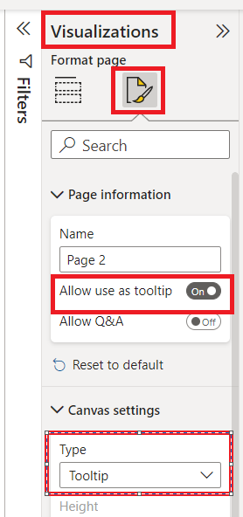

Step 2: Click on Visualization where you want to show tooltip

Final Output

